**Exercise 1: Mocking and Stubbing**

**Scenario:**

**You need to test a service that depends on an external API. Use Mockito to mock the external API and stub its methods.**

**Step 1: Create ExternalApi interface**

package com.rindhiyaa.junit;

public interface ExternalApi {

String getData();

}

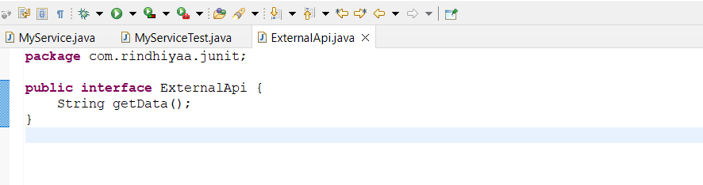

**Step 2: Create MyService class with dependency injection**

**package** com.rindhiyaa.junit;

**public** **class** MyService {

**private** ExternalApi api;

**public** MyService(ExternalApi api) {

**this**.api = api;

}

**public** String fetchData() {

**return** api.getData();

}}

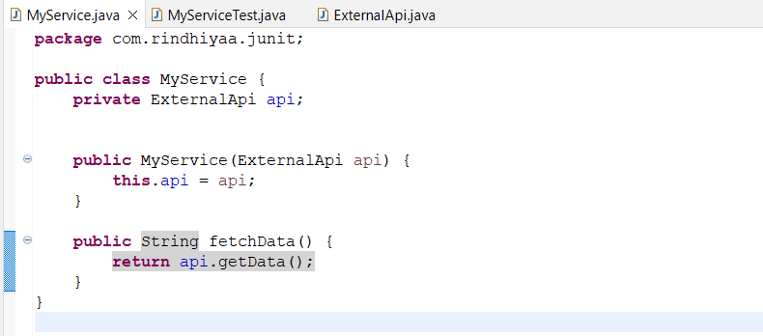

**Step 3: Create JUnit test using Mockito**

**package** com.rindhiyaa.junit;

**import** **static** org.mockito.Mockito.*;

**import** **static** org.junit.jupiter.api.Assertions.*;

**import** org.junit.jupiter.api.Test;

**public** **class** MyServiceTest {

@Test

**public** **void** testExternalApi() {

ExternalApi mockApi = *mock*(ExternalApi.**class**);

*when*(mockApi.getData()).thenReturn("Mock Data");

MyService service = **new** MyService(mockApi);

String result = service.fetchData();

*assertEquals*("Mock Data", result);

System.***out***.println(" Test Passed: Mocked data returned successfully.");

}

}

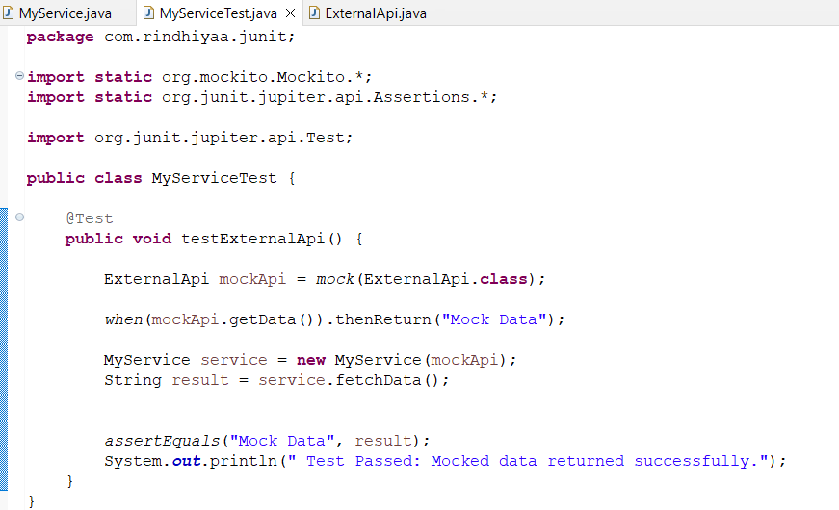

**OUTPUT**

